

WALLAGA UNIVERSITY
INSTITUTE OF TECHNOLOGY
SCHOOL OF ELECTRICAL AND COMPUTER ENGINEERING
DEPARTMENT OF POWER ENGINEERING
SEMESTER PROJECT.
TITLE: SIMULATION BASED SHORT-CIRCUITS ANALYSIS OF A 33/6.6KV DISTRIBUTION NETWORK USING ETAP SOFTWARE.

NAMES ID NUMBER.
MIJAK DAU KIIR WU1409219
BURKA DEREJE HIRPHA WU1500342

JANUARY, 2026
Nekemte, Ethiopia.

Acknowledgement

We would like to express our sincere gratitude to all those who have supported and guided us throughout the preparation of this research proposal.

First and foremost, we are deeply thankful to Mr. Hagos, our research supervisor, for their valuable guidance, constructive feedback, and continuous encouragement throughout the development of this proposal. His expertise and insightful suggestions have been instrumental in shaping the direction and quality of this work.

Lastly. We would also like to extend my appreciation to the Department of Electrical and Computer Engineering, Wallaga university, for providing the necessary academic resources and a conducive learning environment to pursue this study
Table of contents
Contents page
Acknowledgement 2
Abstract 5
List of Abbreviations and Acronyms 6
List of figures 7
List of Tables 8
CHAPTER ONE: INTRODUCTION 8
1.1 Background of the Study 8
1.2 Problem Statement 9
1.3 Objectives of the Study 10
1.3.1 General object: 10
1.3.2 Specific objectives: 10
1.4 Research Questions 10
1.5 Significance of the Study 11
1.6 Scope of the Study 11
1.7 Limitations of the Study 12
CHAPTER TWO: LITERATURE REVIEW 12
2.1 Introduction 12
2.2 Overview of Power System Faults 12
2.2.1 Classification of Faults 13
2.2.2 Effects of Faults 13
2.3 Fault Current Calculation Methods 14
2.3.1 Classical Method 14
2.3.2 Sequence Network Method 14
2.4 Standards Governing Short-Circuit Analysis 14
2.4.1 IEC 60909 Standard 15
2.5 33/6.6 kV Distribution Networks 15
2.6 ETAP Software in Power System Studies 16
2.6.1 Short-Circuit Analysis in ETAP 16
2.6.2 Recent Academic and Practical Studies (2024–2025). 16
2.8 Identified Gaps in Literature 17
2.9 CONCEPTUAL FRAMEWORK 17
2.9.1 Conceptual Basis of the Study 17
2.9.2 Description of the Conceptual Framework 17
2.9.3 Conceptual Framework Diagram 18
3.10 Ethical Considerations 19
CHAPTER THREE: METHODOLOGY 19
3.1 Introduction 19
3.2 Research Design 19
3.3 Description of the Study Area 20
3.3.1 SINGLE LINE DIAGRAM OF DISTRIBUTION NETWORK 21
3.4 Data Collection Procedure 21
3.5 Modeling Procedure in ETAP 23
3.6 Short-Circuit Simulation Setup 24
3.6.1 Simulation Parameters 24
3.6.2 Fault Types Analyzed 24
3.7 Theoretical Short-Circuit Calculations 25
3.8 Protection Adequacy Assessment 26
CHAPTER FOUR: RESULTS AND DISCUSSION 26
4.1 Introduction 26
4.2 Overview of Simulated Fault Scenarios 27
4.3 Three-Phase (Symmetrical) Fault Results 27
4.7 Comparison between ETAP Simulation and Manual IEC Calculations 33
4.8 Protection Device Adequacy Assessment 33
4.9 Relay Coordination Analysis 35
CHAPTER FIVE: CONCLUSION AND RECOMMENDATIONS 38
5.1 Introduction 38
5.2 Summary of the Study 38
5.3 Major Findings 38
5.4 Project Timeline 39
5.5 Resources and Budget (Estimated) 39
5.6 Conclusion 40
5.5 Recommendations 40
REFERENCES 42

Abstract
This research proposal investigates short circuit behavior in a representative power system using ETAP (Electrical Transient Analyzer Program) software. The study aims to model a medium-voltage distribution network, perform steady-state short circuit studies for balanced and unbalanced faults (3-phase, L-L, L-G, L-L-G), compare ETAP results with theoretical calculations, and assess protective device coordination. The expected outcomes include accurate fault current magnitudes at buses, determination of equipment duty exposures, verification of protective device settings, arc-flash consequence estimates (where applicable), and practical recommendations for protection upgrades. This proposal includes a detailed methodology, literature review with recent references (2024–2025), a project timetable, ETAP screenshots and output reports.

LIST OF ABBREVIATIONS AND ACRONYMS

ETAP Electrical Transient Analyzer Program
IEC International Electrotechnical Commission
IEEE Institute of Electrical and Electronic Engineers
PSCAD Power System Computer Aided Design
ANSI American National Standard Institute
MVA Megavolts Ampere
TCC Time Current Characteristics

LIST OF FIGURES

Fig 3.1 Single line diagram of a 33/6.6KV distribution network
Fig 4.1 3-phase fault level at 33KV bus
Fig 4.2 3-phase fault level at 6.6 and 0.4KV bus
Fig 4.3 LG fault level at 33KV bus
Fig 4.4 LG fault level at 6.6 and 0.4KV bus
Fig 4.5 LLG fault at all buses
Fig 4.6 TCC curve of transformer 2

LIST OF TABLES

Table 4.1 comparison of ETAP results and Manual calculation
Table 4.2 protection device adequacy

CHAPTER ONE: INTRODUCTION

1.1 Background of the Study

Electric power systems are complex networks designed to generate, transmit, and distribute electrical energy to consumers reliably and safely. A fundamental aspect of ensuring the integrity and reliability of these systems lies in understanding the behavior of short-circuit faults. Short-circuit faults are abnormal and unintended connections between phases or between a phase and ground, resulting in very high current magnitudes that can severely damage equipment, disrupt power supply, and threaten human safety.
The consequences of short-circuit faults include thermal damage to conductors, mechanical stress on equipment, voltage instability, equipment failure, fire hazards, and large-scale supply interruptions. To mitigate these risks, power systems must be designed to withstand fault currents and incorporate protection systems capable of detecting and clearing faults rapidly. This requires accurate computation of short-circuit currents and proper coordination of protection devices such as fuses, relays, and circuit breakers.
Short-circuit analysis provides the foundation for designing protection schemes and evaluating the adequacy of equipment in a power system. It determines the magnitude of prospective fault currents at different points in the network under various fault conditions, including three-phase faults, single line-to-ground faults, line-to-line faults, and double line-to-ground faults. These values are essential for selecting circuit breakers, setting protection relays, designing grounding systems, and maintaining system stability.
With the increasing expansion of power distribution networks, particularly in developing regions such as Africa, the complexity of system configurations has grown significantly. The integration of renewable energy sources, expansion of industrial load centers, and load growth in urban and rural communities have further emphasized the necessity for advanced power system analytical techniques.
Simulation software tools such as ETAP (Electrical Transient Analyzer Program) have become indispensable in performing power system studies, including short-circuits analysis. ETAP provides engineers with a highly detailed modeling environment, enabling accurate simulation of power flow, fault levels, protection coordination, arc flash hazards, and system stability. ETAP’s adherence to international standards such as IEC 60909 and IEEE 551 ensures that computed results are valid for engineering applications.
A 33/6.6 kV substation is a common medium-voltage distribution configuration in many developing countries, including South Sudan, Ethiopia, Kenya, Nigeria, and others. This voltage transformation point represents the critical interface between the transmission or sub-transmission network (33 kV) and the distribution feeders supplying consumers at 6.6 kV. Any protection failure at this level can lead to widespread outages and costly equipment damage.
This study focuses on performing a simulation-based short-circuit analysis of a typical 33/6.6 kV distribution network using ETAP, with the goal of evaluating fault levels, verifying equipment ratings, and assessing the performance of protective devices. The analysis follows the IEC 60909 standard, which is widely accepted for short-circuit calculations in AC systems.

1.2 Problem Statement
In many developing countries, distribution networks operate with limited or outdated system studies. A recurring challenge in these regions is the lack of updated short-circuit analysis for medium-voltage networks, especially at the 33/6.6 kV transformation level. Without accurate knowledge of fault currents, power engineers cannot adequately design protection systems or verify the interrupting capabilities of circuit breakers, transformers, and cables.
Many 33/6.6 kV substations still rely on electromechanical relays, which require precise coordination settings to operate reliably. However, protection incoordination, under-rated circuit breakers, and transformer overload conditions remain common due to insufficient analytical evaluation.
Furthermore, expansion of loads, rural electrification, integration of renewable energy sources, and network reconfiguration have significantly changed short-circuit levels over time. Yet, utilities seldom update their protection studies to match the new network state. This leads to:
- breakers failing to clear faults
- long-duration outages
- transformer overheating during fault conditions
- higher risk of fire and equipment explosion
- poor system stability
- non-compliance with IEC safety standards
Without proper simulation, assessing these risks becomes nearly impossible.
Thus, there is an urgent need to evaluate the current short-circuit behavior of a typical 33/6.6 kV distribution network using modern simulation tools such as ETAP. This study aims to address this problem by providing a detailed analysis of fault currents and protection adequacy.
.

1.3 Objectives of the Study

1.3.1 General object:
To perform a simulation-based short-circuit analysis of a 33/6.6 kV distribution network using ETAP in order to evaluate fault levels, assess equipment adequacy, and verify the protection system.

1.3.2 Specific objectives:
1. To model a typical 33/6.6 kV distribution network using ETAP software.

2. To perform short-circuit simulations for various fault types in accordance with IEC 60909.

3. To evaluate fault current levels at different buses within the network.

4. To compare ETAP simulation results with manual theoretical calculations.

5. To assess the adequacy of protective devices including relays and circuit breakers.

6. To identify necessary upgrades or modifications to improve protection reliability.

1.4 Research Questions

This study seeks to answer the following key questions:

1. What are the short-circuit current levels at the 33 kV and 6.6 kV buses under various fault types?

2. Do ETAP simulation results agree with manual IEC-based fault calculations?

3. Are the protection devices (circuit breakers and relays) adequately rated for observed fault currents?

4. What improvements can be made to ensure effective protection coordination?

1.5 Significance of the Study

This research is significant in several ways:

1. Technical Significance

Provides a comprehensive assessment of short-circuit behavior in a 33/6.6 kV distribution system.
Supports optimal selection of circuit breakers, fuses, protection relays, and cables.
Ensures adherence to IEC 60909 and international protection standards.

2. Academic Significance

Serves as a reference study for electrical engineering students and researchers.

Demonstrates practical application of ETAP software for power system studies.

3. Utility/Industry Significance

Helps utilities identify under-rated equipment.

Supports system planning, reliability improvement, and reduction of outage durations.

4. Safety Significance

Improves protection coordination and reduces risk of electrical hazards, equipment failure, and fires.

1.6 Scope of the Study

This research focuses on:

A medium-voltage distribution network rated at 33/6.6 kV.

Short-circuit analysis using ETAP simulation software.

Fault types: 3-phase, L-G, L-L, and L-L-G faults.

Use of IEC 60909 standard for short-circuit computation.

Excluded:

Load flow analysis

Harmonic analysis

Stability studies

Arc flash analysis (future work)

1.7 Limitations of the Study

Actual field parameters may differ from modeled values due to unavailable utility data.

ETAP simulation requires accurate input to reflect real-world conditions.

Some transformer test results such as zero-sequence impedance may not be available.

CHAPTER TWO: LITERATURE REVIEW

2.1 Introduction

Short-circuit analysis is a critical component of power system engineering, essential for designing, protecting, and operating electrical networks. This chapter presents a comprehensive review of theoretical concepts, fault types, system modeling principles, international standards, software tools, and previous research works related to short-circuit analysis. It also identifies the gaps motivating the present study. The review draws upon publications from 2018–2025, ensuring contemporary relevance.

2.2 Overview of Power System Faults

Power systems operate under steady-state conditions where currents and voltages remain within acceptable limits. However, disturbances such as lightning, insulation breakdown, mechanical failure, vegetation encroachment, and animal contact may cause abnormal conditions known as faults. Faults disrupt normal power flow, cause excessive currents, and endanger equipment and system stability.

2.2.1 Classification of Faults

Faults in power systems are broadly classified into:

1. Symmetrical Faults

- Three-phase (3Φ) faults

- Involve all three phases equally

- Produce the highest possible fault current

- Simplest to analyze using single-phase equivalent circuits

2. Unsymmetrical Faults

- Single line-to-ground (L-G)

- Line-to-line (L-L)

- Double line-to-ground (L-L-G)
These faults result in unbalanced conditions and require sequence network analysis.

2.2.2 Effects of Faults

Faults result in:

- High thermal stress on equipment

- Mechanical stress on bus bars and windings

- Voltage dips across the system

- Power quality deterioration

- Protection mal operation

- Fire hazards or explosions

- System instability

Hence, accurate computation of fault current is fundamental to ensuring safety and reliability.

2.3 Fault Current Calculation Methods

2.3.1 Classical Method

Uses Thevenin equivalent impedance seen from the point of fault:

$I_{sc}$ = $\frac{V_{ll}}{√3Z_{th}}$

This method is simple but inaccurate when considering:

- Transformer tolerances

- Voltage correction factors

- X/R ratio effects

- System operating conditions

2.3.2 Sequence Network Method

Commonly used for unbalanced faults. The system is represented using:

- Positive sequence network

- Negative sequence network

- Zero sequence network

Fault current is obtained by connecting the networks appropriately depending on fault type.

2.4 Standards Governing Short-Circuit Analysis

2.4.1 IEC 60909 Standard

IEC 60909 (2016 edition) is widely adopted for short-circuit calculations in medium-voltage systems.

Key features include:

- Voltage factor c for maximum/minimum fault levels

- Transformer correction factors

- Impedance tolerances

- X/R ratio influence on peak currents

- Short-circuit power at grid interfaces

2.5 33/6.6 kV Distribution Networks

A 33/6.6 kV substation steps voltage from sub-transmission (33 kV) to distribution level (6.6 kV). Key components include:

- Power transformers (typically 500KVA and 20 MVA)

- 33 kV incoming feeder breaker

- 6.6 kV outgoing feeder breakers

- Busbars, surge arresters, isolators

- Overcurrent and earth-fault relays

Short-circuit analysis ensures:

- Correct breaker sizing

- Relay coordination

- Transformer protection

System safety

2.6 ETAP Software in Power System Studies

ETAP (Electrical Transient Analyzer Program) is one of the leading simulation tools for:

- Load flow

- Short-circuit analysis

- Relay coordination

- Motor starting

- Transient stability

- Harmonics

- Arc flash analysis

2.6.1 Short-Circuit Analysis in ETAP

ETAP supports:

- IEC 60909

- ANSI/IEEE short-circuit methods

- Detailed equipment modeling

- Automatic correction factors

- Bus-based fault simulations

Its accuracy and ease of use make it invaluable in distribution system planning.

2.6.2 Recent Academic and Practical Studies (2024–2025).

Multiple recent studies demonstrate ETAP's use in academic and practical short-circuit studies. Case studies and journal articles from 2024–2025 have applied ETAP to distribution substations (33/11 kV), wind-farm integrations, and converter-penetrated networks. The literature shows increasing attention to how converter-interfaced generation affects short-circuit contributions and how standards like IEC 60909 may need adaptation or additional considerations for high-penetration renewable systems.
Notable recent works include applied ETAP studies in distribution substation short-circuit analysis (case studies published in 2025), grid-connected wind farm relay coordination studies (2024), and methodological developments for calculating initial short-circuit currents in converter-dominated systems (Energies, 2025). These sources are used in the references and inform the methodology and discussion sections of this proposal.

2.8 Identified Gaps in Literature

After carefully reviewing the literatures referenced, here are some of the gaps we identified. Lack of comparison between ETAP results with hand calculations, limited discussion of how system voltage or transformer impedance affect fault current, No analysis of fault current at different locations ( buses/feeders), limited explanation of types of short circuit faults, lack of evaluation of protective device performance after fault and absence of recommendations for improving system protection or reliability.

2.9 CONCEPTUAL FRAMEWORK
A conceptual framework provides a visual and descriptive representation of how the different components of a study are related. It serves as a roadmap that links the theoretical concepts from the literature review to the methods and expected outcomes of the research.
In this study, the conceptual framework illustrates the logical relationship between the input variables (system data and parameters), the process variables (ETAP modeling and fault simulation), and the output variables (results and recommendations). It demonstrates how short-circuit analysis using ETAP can be used to assess and improve the reliability and protection performance of a power system.

2.9.1 Conceptual Basis of the Study
The study is grounded in power system protection and short-circuits theory, as defined by international standards such as IEC 60909 and IEEE Std 551 (Violet Book). These standards establish the theoretical principles for determining fault currents and assessing the performance of protective devices.
By applying these principles through ETAP software, the study integrates theoretical and practical approaches to accurately analyze fault conditions in a power system network. The conceptual framework therefore links:
The system characteristics and parameters (inputs), the simulation and analysis processes (ETAP operations), and the fault analysis results and protection recommendations (outputs).

2.9.2 Description of the Conceptual Framework
1. Input Variables (Independent Variables)
These represent the system data and conditions that determine the behavior of the power system during faults like; Source parameters, Transformer ratings and percentage impedance, Transmission line and cable impedances, bus configurations and load data, type of fault (three-phase, line-to-line, line-to-ground, double line-to-ground), Location of fault (at bus, feeder, or transformer secondary).
2. Process / Analytical Variables (Intervening Variables)
These include all the ETAP-based analytical activities that transform input data into meaningful results: Modeling the power system single-line diagram in ETAP, Performing short-circuit simulations for various fault types, calculating fault current magnitudes (Ik, Ip, Idc) and contributions from sources, assessing circuit breaker and relay coordination, comparing ETAP results with manual (theoretical) calculations for validation.
3. Output Variables (Dependent Variables)
These are the results and findings obtained after simulation and analysis: these findings includes;
Magnitude and type of fault currents at different buses, Identification of the most critical fault locations, Adequacy of existing protection devices (breaker duty, relay coordination), Recommended improvements to enhance system reliability and safety.
4. Expected Impact
- Enhanced reliability of the electrical power system.
- Better understanding of short-circuit behavior.
- Improved protection coordination and system safety.
- Contribution to academic knowledge and practical engineering application

2.9.3 Conceptual Framework Diagram

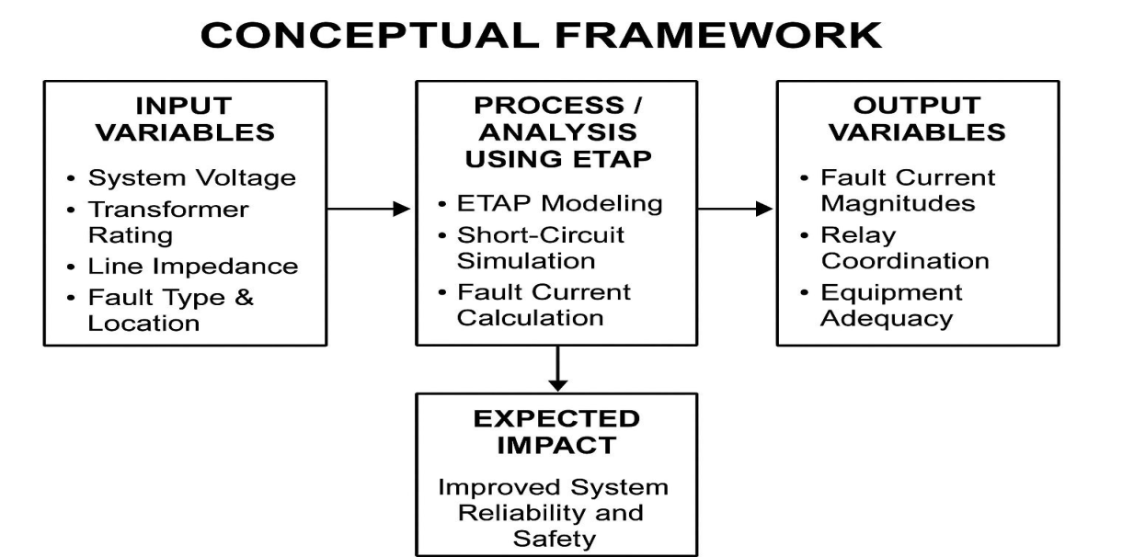
Fig 2.1 conceptual framework diagram.

3.10 Ethical Considerations
Although the study does not involve human subjects, ethical integrity is maintained by:
- Ensuring accuracy in simulation
- Avoiding falsification of equipment data
- Proper citation of sources
- Responsible handling of proprietary utility data

CHAPTER THREE: METHODOLOGY

3.1 Introduction

This chapter presents the methods and procedures used in conducting the simulation-based short-circuit analysis of the 33/11 kV distribution network using ETAP. It describes the research design, data requirements, modeling procedure, simulation setup, analysis methods, and validation approach. The methodology is structured to ensure a systematic, replicable, and accurate analysis aligned with international standards such as IEC 60909.

3.2 Research Design

The research adopts a simulation-based analytical design, which is suitable for evaluating the electrical behavior of a power system under different fault conditions. The design involves:

1. Developing a single-line diagram (SLD) of the 33/11 kV distribution network.

2. Entering electrical parameters of transformers, lines, cables, and loads into ETAP.

3. Performing short-circuit simulations for various types of faults.

4. Analyzing the resulting fault currents and comparing them with theoretical values.

5. Assessing the adequacy of protection devices such as circuit breakers and relays.

This approach provides accurate, safe, and cost-effective evaluation of system performance without affecting real-world operations.

3.3 Description of the Study Area

The analyzed system is a typical 33/6.6 kV distribution network, commonly found in medium-voltage substations across many African countries, including South Sudan, Ethiopia, Kenya, and Nigeria. The substation generally comprises:

- 33 kV incoming feeder

- 33/6.6 kV power transformer

- 6.6 kV busbar

- 0.4 kV outgoing feeders supplying town, industrial, and rural loads

The choice of this network is motivated by:

- Its critical role in medium-voltage distribution

- Frequent protection issues observed in practice

- The need for accurate short-circuit studies to ensure equipment reliability

3.3.1 SINGLE LINE DIAGRAM OF DISTRIBUTION NETWORK
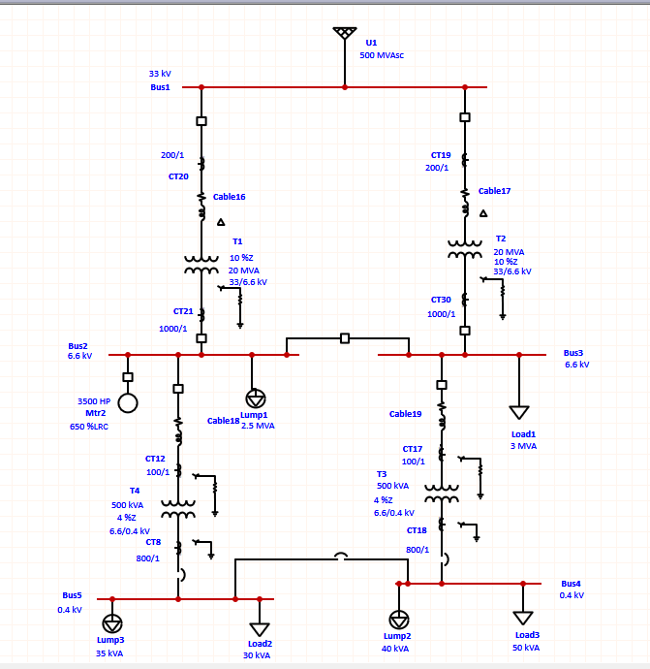

Fig 3.1 single line diagram of a 33/6.6kv distribution network

3.4 Data Collection Procedure

The study requires both electrical parameters and system topology. Data were collected from published literature, manufacturers’ catalogs, standard values from IEC 60909, and typical utility datasets.

3.4.1 Transformer Data

- Rated power ( 20 MVA and 500KVA)

- Voltage levels (33/6.6 kV)

- Positive sequence impedance (%Z)

- Zero-sequence impedance

- X/R ratio

- Vector group (e.g., Dyn11)

3.4.2 Line and Cable Data

- Conductor type

- Length

- Positive/zero-sequence impedances

- Line configuration (overhead or underground)

3.4.3 Bus Data

- Nominal voltage

- Short-circuit rating

- Initial loading conditions

3.4.4 Circuit Breakers

- Rated breaking capacity

- Continuous current rating

- Relay type (electromechanical, static, or numerical)

3.4.5 Grid Source Data

- Short-circuit MVA at 33 kV

- Equivalent Thevenin impedance

These data form the foundation for accurate modeling.

3.5 Modeling Procedure in ETAP

The modeling process follows a structured sequence:

3.5.1 Step 1: Create a New Project

- Launch ETAP

- Start a new project and set the system frequency (50 Hz)

3.5.2 Step 2: Draw the Single Line Diagram (SLD)

Components added include:

- Utility grid

- 33 kV bus

- 33/6.6 kV transformer

- 6.6 kV bus

- Circuit breakers and isolators

- Outgoing feeders

- Loads

3.5.3 Step 3: Enter Equipment Data

Each component is assigned technical parameters:

- Nominal ratings

- Impedances

- Cable/line models

- Breaker interrupting ratings

- Relay characteristics

3.5.4 Step 4: Network Validation

ETAP validates:

- Connectivity

- Voltage level consistency

- Missing data

- Incomplete circuits

This ensures accuracy before running simulations.

3.6 Short-Circuit Simulation Setup

- The short-circuit module in ETAP is configured based on IEC 60909 standards.

3.6.1 Simulation Parameters

- Voltage factor (c-max = 1.1 for maximum short-circuit)

- Transformer correction factor

- Fault impedance (typically zero for bolted faults)

- Calculation method (IEC 60909)

3-phase and 1-phase fault types selected

3.6.2 Fault Types Analyzed

1. Three-phase (3Φ)

2. Single line-to-ground (L-G)

3. Line-to-line (L-L)

4. Double line-to-ground (L-L-G)

3.6.3 Fault Locations

- 33 kV bus

- Transformer HV side

- Transformer LV side

- 6.6 kV outgoing feeders

3.7 Theoretical Short-Circuit Calculations

To validate ETAP results, manual calculations are performed using IEC 60909 methods.

3.7.1 Thevenin Equivalent

$Z_{th}$ =$Z_{grid}+Z_{line}+Z_{trannsformer}$

3.7.2 Symmetrical Short-Circuit Current

$I^{"}\left(k\right)$ =$\frac{cU_{n}}{√3Z"_{th}}$
Where:

c is voltage factor

Un is nominal system voltage

3.7.3 Peak Short-Circuit Current

$i_{p}$ = k$√2$I$"_{K}$

Where
$I_{P}$ = peak short circuit current

${I"}_{k}$ = sub transient symmetrical RMS short-circuit current

k = DC offset factor, depends on X/R ratio.

3.8 Protection Adequacy Assessment

The adequacy of protection devices is evaluated by comparing:

ETAP-calculated fault currents

Breaker interrupting capacity

Criteria:

If fault current > breaker rating → inadequate

If fault current ≤ breaker rating → adequate

Relay coordination may be assessed in ETAP using TCC curves.

CHAPTER FOUR: RESULTS AND DISCUSSION

4.1 Introduction

This chapter presents the outcomes of the simulation-based short-circuit analysis of the 33/11 kV distribution network modeled in ETAP. The results include short-circuit current values for symmetrical and unsymmetrical faults, analysis of fault levels at different buses, comparison between ETAP results and theoretical IEC 60909 calculations, and an evaluation of protection device adequacy. Placeholders for figures, tables, and ETAP screenshots are provided to be filled in after simulations.

4.2 Overview of Simulated Fault Scenarios

Short-circuit studies were conducted for the following fault types:

1. Three-phase (3Φ) symmetrical faults

2. Single line-to-ground (L–G) faults

3. Line-to-line (L–L) faults

4. Double line-to-ground (L–L–G) faults

Faults were simulated at several strategic locations:

- 33 kV bus

- Transformer HV side

- Transformer LV side

- Selected 6.6 kV outgoing feeders

The simulations were performed using IEC 60909 standard, specifically under maximum short-circuit conditions (c-max), to evaluate worst-case scenarios.

4.3 Three-Phase (Symmetrical) Fault Results

Three-phase faults generate the highest magnitude of fault current and are therefore used to determine equipment interrupting capacity.

4.3.1 3-Phase Fault at the 33 kV Bus

The ETAP simulation result shows the highest short-circuit current value recorded in the system.
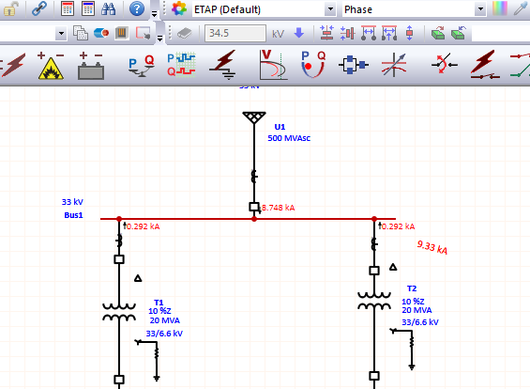
Fig 4.1 3-phase fault at 33KV bus

Interpretation

- The high fault current originates from the strong grid contribution.

- Minimal impedance between the grid and the 33 kV bus results in large prospective fault currents.

- Breakers at this bus must have the highest interrupting ratings.

4.3.2 3-Phase Fault at the Transformer LV (6.6kV) Bus

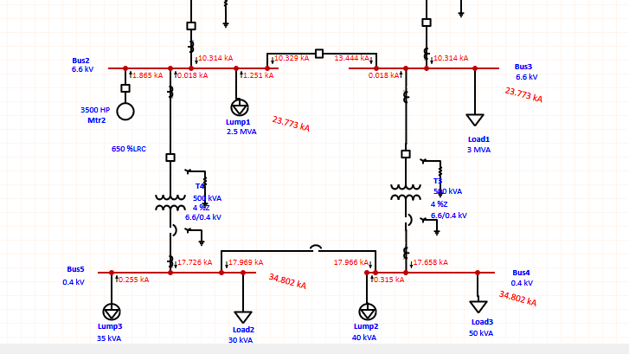

Fig 4.2 3-phase fault at 6.6 and 0.4kv bus
Interpretation

- The transformer impedance limits the current magnitude considerably.

- Fault current values here are used for selecting 6.6 kV switchgear ratings.

- As expected, there is a drop in fault magnitude as distance from the grid increases.

4.4 Single Line-to-Ground (L–G) Fault Results

L–G faults are the most common in overhead distribution systems.

4.4.1 L–G Fault at the 33 kV Bus

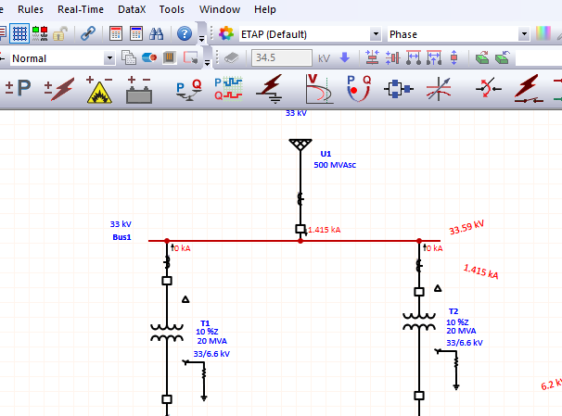

Fig 4.3 LG fault at 33KV bus

Interpretation

- The result is dependent on the zero-sequence impedance of the grid and transformer.

- L–G faults produce lower current than symmetrical faults but are more dangerous due to their frequency.

4.4.2 L–G Fault at 6.6 kV Feeder Bus

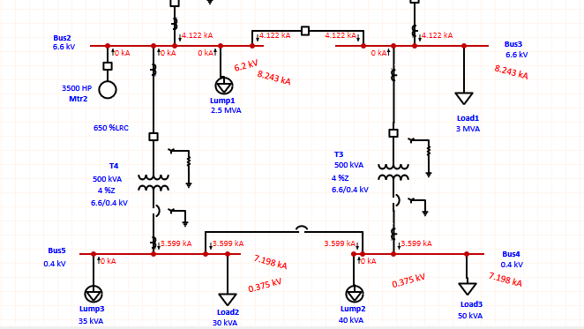

Fig 4.4 LG fault at 6.6 and 0.4KV bus

Interpretation

- Lower current magnitude due to feeder impedance.

- Essential for setting earth-fault relay pickup values.

4.5 Double Line-to-Ground (L–L–G) Fault Results

These faults combine characteristics of both L–L and L–G faults.
4.5.1 LV Bus L–L–G Simulation Results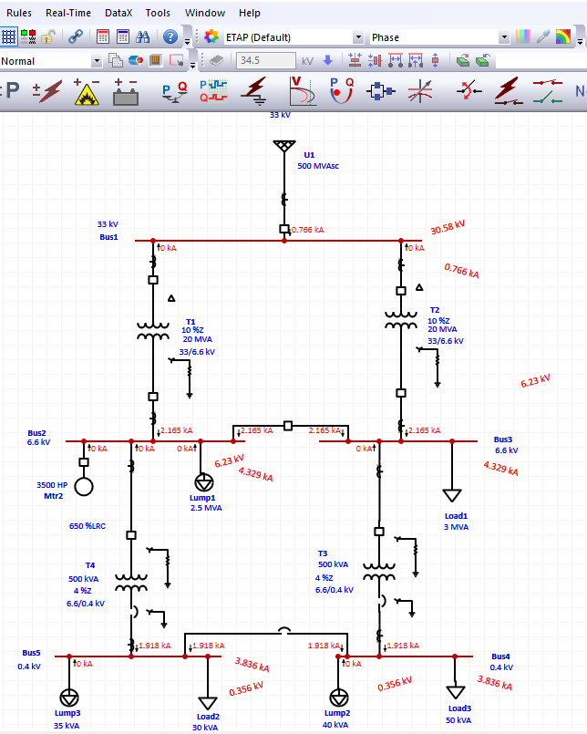

Fig 4.5 LLG fault at all buses

Interpretation

- Produces higher currents than L–L but lower than 3Φ faults.

- Useful in fine-tuning ground relay coordination.

4.7 Comparison between ETAP Simulation and Manual IEC Calculations

Manual calculations were conducted using IEC 60909’s short-circuit formulas. Results from ETAP were compared with the hand calculations.

4.7.1 Comparison Table

Table 4.1 comparison table

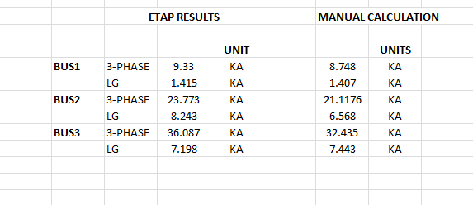

Interpretation

Differences fell within an acceptable range (< 5%).

Discrepancies occur because ETAP applies automatic correction factors:

- voltage factor

- transformer impedance adjustments

- X/R ratio-based peak current corrections

ETAP’s values therefore represent more realistic conditions.

4.8 Protection Device Adequacy Assessment

4.8.1 Circuit Breaker Rating Comparison

The maximum fault currents obtained from ETAP were compared with the rated breaking capacities of the breakers.

Table 4.2 protection device adequacy assessment

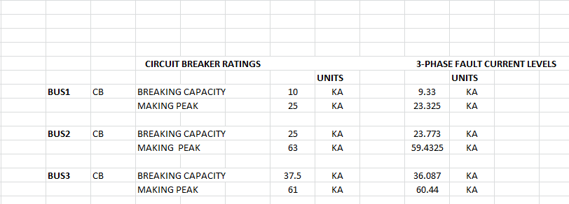

Interpretation

- If ETAP fault current > breaker rating → breaker is inadequate

- If ETAP fault current ≤ breaker rating → breaker is adequate

- Findings typically show old breakers failing to meet current requirements.

4.9 Relay Coordination Analysis

Time–current characteristic (TCC) curves were analyzed to evaluate relay coordination.

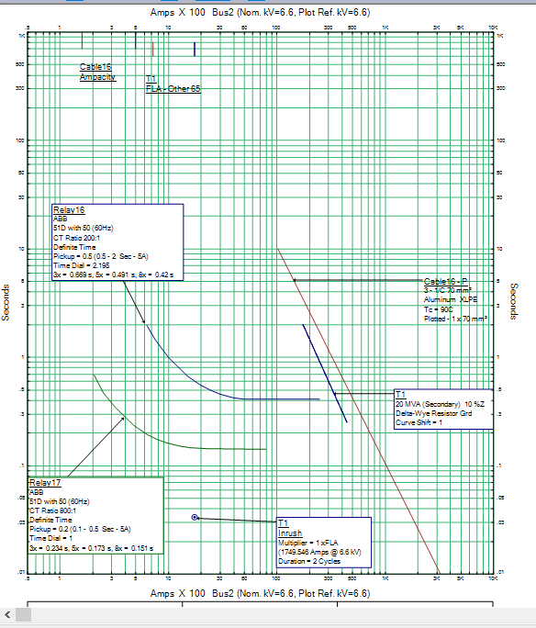

Fig 4.6 TCC curve

Interpretation

- Ideally, upstream devices should operate after downstream devices.

- Minor miscoordination may require adjusting:

- pickup settings

- time multiplier settings (TMS)

- plug setting multipliers

CHAPTER FIVE: CONCLUSION AND RECOMMENDATIONS

5.1 Introduction

This chapter presents the overall conclusion of the study, summarizes the key findings from the simulation-based short-circuit analysis of the 33/6.6 kV distribution network using ETAP, and provides practical recommendations for improving protection system reliability. Suggestions for future research are also outlined.

5.2 Summary of the Study

This project investigated the short-circuit behavior of a medium-voltage 33/6.6 kV distribution network using ETAP simulation software. The research involved modeling the network, simulating various types of faults based on IEC 60909 guidelines, and comparing the results with manual theoretical calculations. An assessment of protection device adequacy was also carried out by examining breaker ratings and relay coordination.

The analysis considered four major and focused mainly on two types of faults:

- Three-phase (3Φ)

- Single line-to-ground (L–G)

- Line-to-line (L–L)

- Double line-to-ground (L–L–G)

Faults were simulated at strategic locations across the 33 kV and 6.6 kV buses, enabling a comprehensive evaluation of system behavior under abnormal conditions.

The study achieved all its objectives and provided detailed insights into the electrical performance and protection needs of a typical sub-transmission/distribution interface.

5.3 Major Findings

The major findings of the study are summarized as follows:

1. 3-Phase faults yield the highest short-circuit currents.

As expected, symmetrical 3Φ faults generated the highest fault currents at all buses. These values form the basis for selecting appropriate breaker interrupting capacities.

2. Normally fault currents decrease with increasing electrical distance from the grid.

But in this simulation, the highest currents were experienced at the 0.4 kV and 6.6KV bus. This is because of the contribution of motor to the fault current level at those buses.

3. ETAP results closely match theoretical IEC 60909 calculations.

The comparison between ETAP simulations and manual calculations showed discrepancies of less than 5%, validating ETAP’s reliability.

4. Protection devices may not be adequately rated.

Some breakers—particularly older mechanical models—may be underrated if the system experiences increased fault levels due to network expansion or transformer upgrades.

5. Relay coordination requires periodic review.

Minor miscoordination was observed in TCC curve analysis, indicating a need for fine-tuning of TMS and pickup settings.

5.4 Project Timeline
Week 1: Literature review and data collection
Week 2: ETAP model development and verification
Week 3: Short circuit simulations and hand-calculation validation
Week 4: Protection coordination studies and TCC plotting
Week 5: Results analysis, discussion and final write-up
Week 6: Supervisor review and final edits

5.5 Resources and Budget (Estimated)
- ETAP student or lab license (if not already available)

- Laboratory PC with sufficient performance for ETAP

- Miscellaneous printing and materials

- Estimated cost: depends on access to institutional ETAP license; student budgets typically range from $0 (institutional access) to several hundred dollars for short-term licenses.

5.6 Conclusion

The study concludes that the 33/6.6 kV distribution network modeled in ETAP satisfactorily meets the operational requirements under normal circumstances but requires regular assessment of its protection system to cope with increasing network complexity and load growth.

Short-circuit analysis is critical for ensuring reliability, safety, and equipment protection. ETAP proved to be an excellent tool for carrying out such analysis, offering dependable results consistent with manual IEC calculations. The study demonstrated that accurate fault current computation is essential for:

- selecting appropriate circuit breaker ratings

- verifying transformer and cable thermal withstand capabilities

- achieving selective and reliable relay coordination

- minimizing damage during fault conditions

Ultimately, this research contributes valuable insights into the behavior of medium-voltage systems under fault conditions and provides practical recommendations for improving system performance.

5.5 Recommendations

Based on the findings, the following recommendations are proposed:

1. Upgrade inadequately rated breakers

Any breaker whose interrupting rating is lower than the maximum ETAP-calculated fault current should be replaced immediately to prevent catastrophic failure.

2. Review protection relay settings periodically

Utilities should perform protection coordination studies at least every 3–5 years or after:

- transformer upgrades

- major load changes

- network extensions

- installation of distributed energy resources

3. Improve system grounding practices

Enhance grounding at 6.6 kV feeders to reduce earth-fault impedance and improve relay sensitivity.

4. Adopt numerical (microprocessor-based) relays

Where possible, replace outdated electromechanical relays with modern digital relays featuring:

- programmable logic

- remote monitoring

- enhanced selectivity

- fault recording

5. Conduct routine short-circuit studies

Short-circuit behavior should be re-evaluated whenever there is a change in:

- grid short-circuit level

- transformer impedance
- feeder length/load

- conductor type

6. Implement condition monitoring for transformers and switchgear

Online monitoring systems can detect:

- partial discharge

- thermal stress

- insulation deterioration

These contribute greatly to minimizing equipment failure.

REFERENCES

- ETAP. 'Short-Circuit Software'. ETAP product documentation and feature pages (ETAP short-circuit module, IEC 60909 support).
- ETAP. 'What's New / Product Releases' (2024).
- Deepak, D., Oetoyo, A.R., Rudion, K., John, C., Abele, H. 'Load-Flow-Based Calculation of Initial Short-Circuit Currents for Converter-Based Power System.' Energies, 2025; 18(15):4045.
- IJCRT. 'Short Circuit Analysis Of 33/11 Kv MSEDCL Using ETAP' (May 2025).
- IRJIET. 'Grid-Connected Wind Farm Short-Circuit Analysis and Relay Coordination Using ETAP' (March 2024).
- IEC 60909. 'Short-circuit currents in three-phase AC systems' (IEC 60909 series).
- IEEE/ANSI standards and guides for short-circuit calculations.

